|  |  |  |
| --- | --- | --- |
|  | | |
|  |  |
|  | | |

|  |  |
| --- | --- |
| 180 Battery Street, Suite 350 Burlington, VT 05401 802.383.0118 **www.rsginc.com** | **prepared for:** |
| Town of Williston | CCRPC |
| **Submitted By:** |
| rsg |
|  |
|  |

1.0 Introduction 1

1.1 Background 1

1.2 How To Use This Guide 1

2.0 Using SPA 3

2.1 Install the Tool 3

2.2 Input Files 4

Parking Lots File 4

Generators File 5

Land Use Demand File 6

Adjustment Factors File 6

2.3 Running the Tool 7

First Run 7

Rerun the Tool with the Same Inputs 7

3.0 Output Data and Results 9

3.1 Output Data 9

3.2 Display Results 10

4.0 Example Analysis 12

4.1 Existing Conditions 12

Parking Lots File 12

Generator File 12

Land Use Demand and Adjustment Factor Files 13

Results 13

4.2 Adding a New Generator 13

New Generator Excel File 14

Results 14

5.0 Calibration and Refining Input Data 15

6.0 Creating Input Files 16

6.1 Create Parking Lot Preference List 16

6.2 Create Generator and Parking Lots Input Files 18

Generator File 18

Parking Lots File 19

6.3 Create Adjustment Factors File 20

**List of Figures**

Figure 1: Open arcToolbox Pane 3

Figure 2: Add Toolbox... 3

Figure 3: Navigate to Parking Analysis Toolbox 3

Figure 4: Parking Analysis Toolbox 4

Figure 5: Example Parking lOt File Format 5

Figure 6: Example Generators File format 6

Figure 7: Example Land Use Demand Factors File Format 6

Figure 8: Generate Parking Demand tool 7

Figure 9: Open tool properties 8

Figure 10: Enter default parameter for tool 8

Figure 11: Example Output CSV file format 9

Figure 12: Report Output 10

Figure 13: Select the data to be deleted 10

Figure 14: Refresh the data in the pivot table 10

Figure 15: Example results 11

Figure 16: Pivot Table Filters 11

Figure 17: Walmart and Home Depot Parking Lots 12

Figure 18: Walmart/Home Depot Parking Lots File 12

Figure 19: Walmart/Home Depot Generators File 13

Figure 20: Existing Conditions Results 13

Figure 21: WALMART/HOME DEPOT Plus Restaurant GENERATORS FILE 14

Figure 22: Existing Conditions Results (left) and Results with new restaurant (right) 14

Figure 23: Employment and Parking lot data displayed with only the Home Depot and Walmart locations and associated parking lots highlighted 16

Figure 24: Open the Generate Parking Preference Tool 17

Figure 25: Use the pulldown menu when selecing data 17

Figure 26: Original data grouped as "Original Data" 17

Figure 27: Generator and parking data created by the Generate Parking Preference tool 18

Figure 28: Parking lot preferences by generator 18

# Introduction

## Background

This user guide provides instructions for the Shared Parking Analysis (SPA) tool, developed by RSG with support from the Town of Williston and the Chittenden County Regional Planning Commission. The SPA tool models shared parking demand for specific geographic areas based on land use and adjustment factors by month, day of week, and time of day. Factors from Shared Parking, Second Edition by the Urban Land Institute*[1]* (ULI) are incorporated by default, but other factors could be used. SPA is designed to be run through ArcMap using Excel files as inputs. Although SPA was designed for the Town of Williston, it can analyze shared parking anywhere that the necessary data is available.

SPA provides an understanding of the parking supply needs of a set of parking generators in relation to the available parking spaces. First it calculates parking demand for each parking generator for all time combinations. The combination dimensions from Shared Parkingare:

* Time of Day: 6 AM – Midnight
* Day: Weekday or Weekend
* Time of Year: all 12 months and December after Christmas (termed “Late December”)

The user assigns each generator a list of parking lots in order of preference, and then SPA allocates each generator’s parking demand. If a generator’s first choice lot is already full, its demand is moved to its second choice. The model continues to allocate demand until all demands are met or no parking spots are available.

The tool creates a csv file of parking lot utilization for all factor combinations and a report noting the time of highest parking use and any times where there was insufficient parking for a particular generator.

## How To Use This Guide

This guide will help the user understand how to run SPA. To run the SPA tool:

* Install the tool
* Create the *Parking Lots* input file
* Create the *Generators* input file
* Create shared parking demand and adjustment factors, or use the default data supplied with the tool
* Run the tool
* Check the outputs for reasonableness

This guide provides chapters on:

* Preparing SPA inputs
* Running the SPA tool
* Analyzing the results
* Testing the effect of adding a new generator to an existing population of parking lots and generators
* Refining the input data with real world observations

File names are in *italics*.

Tab names in an Excel file are in **bold**.

# Using SPA

## Install the Tool

The SPA tool is a standard ArcMap script tool inside a toolbox. Install the tool the same way any new toolbox is opened in ArcMap:

* Open the ArcToolbox window from the Geoprocessing pulldown menu 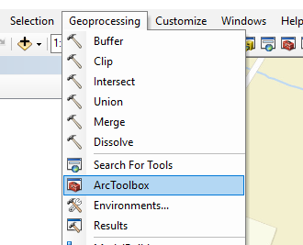

Figure : Open arcToolbox Pane

* Right-click in the white space of the Toolboxes pane and choose “Add Toolbox…” 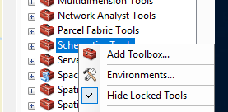

Figure : Add Toolbox...

* Navigate to the Shared Parking Analysis toolbox 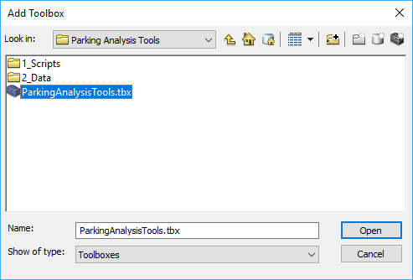

Figure : Navigate to Parking Analysis Toolbox

* The Parking Analysis Tools toolbox appears in the ArcToolbox pane

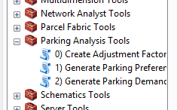

Figure : Parking Analysis Toolbox

* Open the tool by double-clicking the script tool **2) Generate Parking Demand**.
* The tool opens. The user points to the input files specified below.

## Input Files

The **Generate Parking Demand** tool has four input files:

* *Parking Lots* file (Excel file, user created)
* *Generator*s file (Excel file, user created)
* *Land Use Demand* file (Excel file, default or user created)
* *Adjustment Factors* file (python pickle file, default or user created)

The Excel files have all necessary data on one sheet which SPA reads in, but other sheets may be present in the Excel file if it is useful. In the case of the templates provided, the main sheet pulls data from other sheets, but these other sheets are not required.

This section describes the contents of these input files. Section 6.0 below describes in more detail how these files can be created from geographic data and the Excel templates provided, but the inputs can simply be entered by hand if that is easier. Typically, a small number of generators and parking lots can be quickly entered by hand, but a large number are easier to derive from available geographic data. It is recommended to open the default files provided with the tool while reading this section for an example.

The user is responsible for creating these files the first time a model is run in a new area. The files can be reused for subsequent model runs.

### Parking Lots File

This Excel file contains parking lot information with the following headings:

* Name – the lot name. This column is not used in the tool and is to help the user identify the generator.
* Lot number (unique ID for each lot). The default column name is Lot_UID, which is created by the “Generate Parking Preferences” script (see Section 6.0 below).
* Spaces – The number of spaces in each lot



Figure : Example Parking lOt File Format

### Generators File

This Excel file contain information about the parking generators that use the parking lots in the *Parking Lots* file. It has the following headings:

* Name – Name of the parking generator. This column is not used in the tool and is to help the user identify the generator.
* Location – Unique ID number typically associated with a GIS file, but a GIS association is not required.
* LUC – Land Use Code of a particular generator’s land use. This number must match a land use code in the *Land Use Demand* file and *Adjustment Factors* file.
* Type – Description of the type of land use. This column is not used in the tool and is to help the user develop the *Generators* file.
* Size – The size of the generator based on its unit.
* Unit – The unit in which size is measured. The unit type must match the Land Use’s unit type in the *Land Use Demand* file.
* Gen_ID – Unique ID associated with each generator. This ID number is created by the “Generate Parking Preference” script and is used to associate parking lots and generators when the user created the *Generators* file. It is not used by the SPA tool and is not required.
* ParkingLots – A list of parking lot unique IDs (from the Lot Number column in the *Parking Lots* file) separated by semicolons. The parking lots are in order of preference of the particular generator, e.g. patrons of Asian Bistro in Figure 6 will first try to park in lot 18, then lot 2, then lot 5, etc.

The user should use their best judgement when determining parking lot preference order. If a lot is close to a generator but lacks a pedestrian walkway or adequate wayfinding, people may not use it. A future project that improves pedestrian access to a generator may allow additional lots to be included in this list.



Figure : Example Generators File format

### Land Use Demand File

This Excel file contains parking demand ratios for the land uses in the *Generators* file. These ratios and their corresponding adjustment factors can come from any source. Currently, the SPA tool uses demand factors and adjustments from the second edition of Shared Parking, but different data can be used as long as it maintains the same format.

* LUC – Land Use Codes. These numbers can be arbitrary, but they must match the land use codes in the *Generators* file (LUC column).
* Land Use – Description of the type of land use. This column is not used in the tool.
* User – Either “Visitor/Customer” or “Employee.” These two types of users have different parking demand ratios. In the case of housing, residents’ parking demand appears under “Employee.”
* Weekday – Weekday demand ratio, the number of parking spaces per unit required at peak weekday times.
* Weekend – Weekend demand ratio, the number of parking spaces per unit required at peak weekend times.
* Unit – The units which correspond to the demand ratios.



Figure : Example Land Use Demand Factors File Format

### Adjustment Factors File

The *Adjustment Factors* file contains all combinations of monthly, daily, and time of day adjustment factors. It is a python pickle file with the “.p” extension. The python script will read this file to load a pandas DataFrame of the various adjustment factors. See Section 6.3 below for more information on creating the *Adjustment Factors* file. Using this pickle file pre-compiles the adjustment combination and decreases the tool’s runtime.

## Running the Tool

### First Run

The Generate Parking Demand tool is run as a typical ArcMap tool.

Double-click **2) Generate Parking Demand** to open the tool. Several fields populate with default sheet and column names. The user is responsible for pointing the tool to correct files and confirming that the column names are correct.

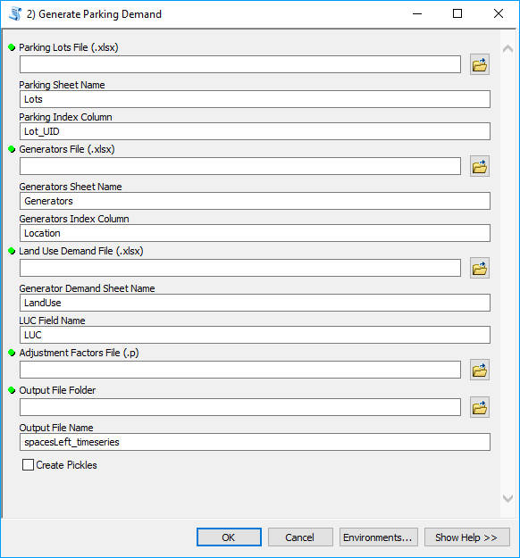

Figure : Generate Parking Demand tool

Choose the three Excel files (*Parking Lots*, *Generators*, and *Land Use Demand*) and the *Adjustment Factors* pickle file.

The default sheet names and index column names match those in the template files provided with the tool and should not be changed unless the user changed them in the Excel files.

Choose the Output Folder in the “Output File Folder” field and change the Output File Name if desired.

If “Create Pickles” is selected, the tool will save pickle files to the Output File Folder. These can be used to load pandas DataFrames of the parking lots’ supply and generators’ demand into python. Only check this box if you plan to explore the output data in python.

Click “OK” and the tool will run.

### Rerun the Tool with the Same Inputs

To rerun the tool with the same inputs, there are two options. One is to open the tool run from the Results pane (Geoprocessing > Results). The other option is to define default inputs for the parameter in the tool. Right-click the tool in the Catalog or ArcToolbox window and choose “Properties” (Figure 9).

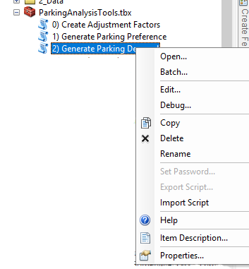

Figure : Open tool properties

Choose the parameter in the top window, e.g. Parking Lot File. Then enter the file path in the “Default” Parameter Property below (Figure 10).

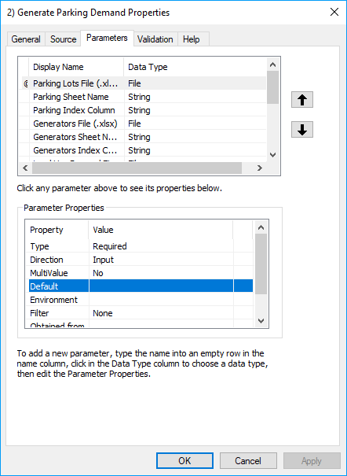

Figure : Enter default parameter for tool

# Output Data and Results

## Output Data

SPA creates a csv file showing the spaces left and the percent utilization of input parking lots for all combinations of adjustment factors.



Figure : Example Output CSV file format

* The file has the following headings:ObjectID - A unique ID number for each line.
* Lot_UID - Signifies the parking lot number from the Lot_UID column in the Parking Lots input file.
* spcsLeft - The number of spaces left in that lot at that time (see timeStmp column).
* pcntFull - The ratio of spaces used to total spaces in that lot at that time, e.g. “0.12” means that 12% of total spaces are in use.
* timeStmp - Provides a timestamp as both an indication of the adjustment factors used and allows the csv to be used as timeseries data in ArcMap. The timestamp has the following format:

| Year Month Day Hour Minute Second



* + Year – This is a place holder not used in the model.
  + Month – This indicates the monthly adjustment factor. 12 can be December or Late December.
  + Day – This indicated the day adjustment factor. 01 is for weekday and 05 is for weekend. 11 and 15 are weekday and weekend in Late December, respectively.
  + Hour – This indicates the time of day adjustment factor
  + Minute – This is a place holder not used in the model.
  + Second – This is a place holder not used in the model.

The Excel file *Display Results* automatically converts the timestamp string into its meaningful time parts (month, day, hour) for analysis.

SPA also creates a report with the suffix “_report.txt” in the same folder as the csv file. This report states the month, day, and time, where utilization was the highest, i.e., fewest parking spots available, across all parking lots. It also notes any times where a generator’s demand was not fully served.

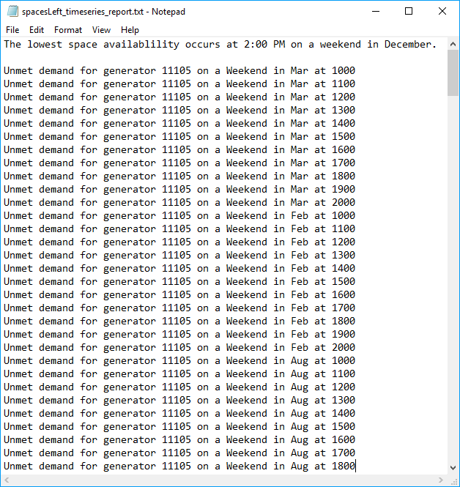

Figure : Report Output

## Display Results

The results contain approximate 500 datapoints for each parking lot. The Excel file *Display Results*, provided in the Output folder, is used to display this data in a manageable format.

* Open the *Display Results* file in Excel and Save As to a new file.
* Select the data in the “CSV Output” section and press the “Delete” key.
  + Ctrl + Shift + Down Arrow keys allows for faster cell selection

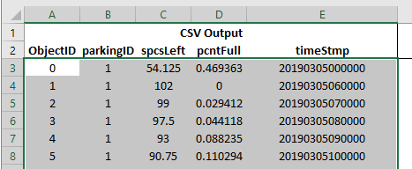

Figure : Select the data to be deleted

* Open the csv file created by SPA
* Copy the data from the csv file and paste values into the “CSV Output” section.
* Right-click on the pivot table and choose “Refresh”

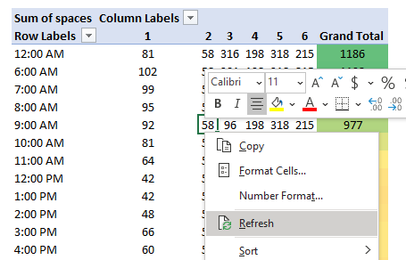

Figure : Refresh the data in the pivot table

* The pivot table will update with the data from the SPA output.



Figure : Example results

The results show the number of parking lot spaces available by lot (identified in the columns by Lot_UID) and time for the selected month and day (weekday or weekend). The Grand Total column sums the available spaces for all lots displayed.

The data displayed on the pivot tables can be changed by selecting different filters.



Figure : Pivot Table Filters

* Change the month or day with the upper filters.
* Change the parking lots being displayed with the Column Labels filter
* It is helpful to have a map of the parking lots when looking at the data to match parking lot numbers with the physical parking lot.

The user should check these results for reasonableness. Do they generally agree with the user’s expectation? Do they agree with anecdotal data on this location? If not, the user should double check the inputs and consider if there are special cases in this area that do not conform well with the default demand and adjustment factors.

# Example Analysis

## Existing Conditions

The example below looks at the parking in the lots between Walmart and Home Depot. The calculation includes separate lines for the salon and optometrist located inside the Walmart. All input files are included with the tool in the Example Data folder or the Source Data folder. This data is based on available databases and is data is meant to be an example only. It may not be accurate, but it is accurate enough for the example purposes.

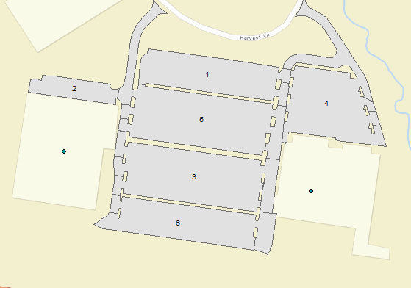

Home Depot

Walmart

Salon

Optometrist

Figure : Walmart and Home Depot Parking Lots

### Parking Lots File

The six parking lots are represented in the *Parking Lots* Excel file.



Figure : Walmart/Home Depot Parking Lots File

### Generator File

The four generators are represented in the *Generators* Excel file.



Figure : Walmart/Home Depot Generators File

### Land Use Demand and Adjustment Factor Files

This analysis uses the default demand and adjustment factors. No changes have been made

### Results

The results show that the highest demand is at 2 PM on a weekend in December. Lots 3 and 6 are full in the afternoon, but there are still 378 spots available across all the parking lots.

 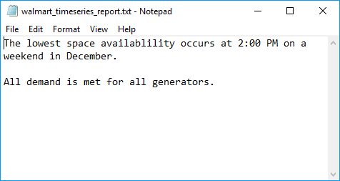

Figure : Existing Conditions Results

Note that lots 1, 2, and 4 have no one parking in them. The tool assumes that people continue parking in a generator’s preferred lot until it is full. In reality, people would probably park in these lots as lots 3, 5, and 6 began to fill up, but the tool’s abstraction is adequate for the shared parking analysis. The Grand Total column combines all lots’ availability into one place.

## Adding a New Generator

Now we will add a new restaurant to the area above parking lot 1. The restaurant is a 5,000 square-foot casual dinner/lunch place (LUC 20). Patrons will park in lot 1 first and then lot 5.

The restaurant will not create any new parking, so the same Parking Lot file is used.

### New Generator Excel File

The new *Generators* file starts with the existing conditions file and then adds a line for the new restaurant. The values in the Location and Emp_UID columns are arbitrary and can be anything as long as they are unique in their column. The restaurant is not associated with any geographic data in this example. The ParkingLots column of parking lot preference order is based on the user’s understanding of how new patrons will behave.



Figure : WALMART/HOME DEPOT Plus Restaurant GENERATORS FILE

### Results

The results of the existing conditions scenario and the new restaurant scenario are shown below. The restaurant has a peak demand of 100 spots (8 PM). However, the lowest availability of spots was reduced by 49 (378 spots – 329 spots) because the peak demands occur at different times.

 

Figure : Existing Conditions Results (left) and Results with new restaurant (right)

# Calibration and Refining Input Data

The SPA tool uses a generic dataset of national data from Shared Parking. It should be used as a planning tool to understand the effects of shared parking, both where excess capacity may exist and where a new generator may require more parking than is currently available. Like all planning data, the demand and adjustment factors used here are not perfect, and the user should be careful when demand is shown to be close to supply.

There are a variety of reasons a user may want to change the demand and adjustments factors. A user may decide to use local data for time adjustment factors or use a higher generation rate for a particularly popular generator. The available land use codes may not cover a desired land use type. Shared Parking explains its methods for data collection and how to collect local data.

A good first step is to perform field counts at the times the SPA tool indicates peak demand occurs. It may also be helpful to compare anecdotal data for particular times with what the tool’s output indicates. These observations may show that the tool is generally accurate, or over- or under-estimating peak demand. It is also possible that some stores are not open when the default factors are showing they have demand, e.g. restaurants that are not open after midnight.

If the user determines that the demand and adjustment factors need to be refined, the user should perform parking lot counts in accordance with the Shared Parking methodology. It may be possible to perform counts at only the times of highest demand and adjust the factors accordingly and thus avoid counting all 26 days of factors. Changing factors to reflect store hour hours will also help calibrate a particular area.

After the new factors have been determined, see Section 6.3 Create *Adjustment Factors* File for more information on creating a new *Land Use Demand* Excel file and *Adjustment Factor* pickle file.

# Creating Input Files

The Shared Parking Analysis Tool is designed to work with the Excel input files described in Section 2.2 Input Files. This section describes creating the input files from the Williston Employment and Parking shapefiles that come with the tool, but the user can also create the input files a different way or from different source data as long as the final input files have the columns described in Section 2.2. The Employment shapefile used in this example contains the parking generators to be studied, but the user could also use non-employment-related sources of parking generation, such as housing.

## Create Parking Lot Preference List

Open ArcMap

Load the Employment point shapefile.

Load the Parking Lot polygon shapefile.

Select the employment points and parking lot polygons to include in the analysis. Figure 23 shows only the point locations Home Depot and Walmart and their associated parking lots highlighted. Only these points and polygons will be included in the analysis.

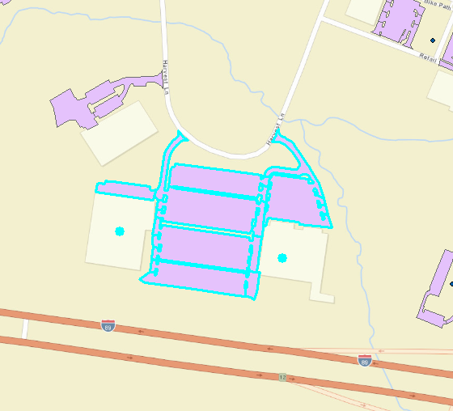

Figure : Employment and Parking lot data displayed with only the Home Depot and Walmart locations and associated parking lots highlighted

Double-click Generate Parking Preference tool in Parking Analysis Tools toolbox to open the tool (Figure 24).

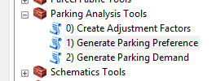

Figure : Open the Generate Parking Preference Tool

Choose Employment and Parking layers from pulldown menus in the tool for the Generator Point File and Parking Polygon File, respectively

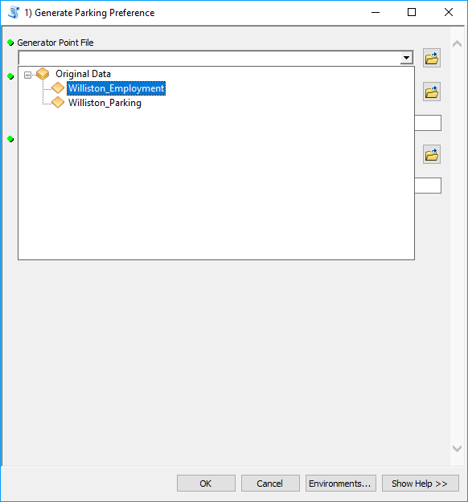

Figure : Use the pulldown menu when selecing data

Fill in the other three fields:

* Max Walking Distance – the maximum distance people will walk from a parking spot to a destination
* Output Data Folder – the folder the output data will be saved to
* Output Preference File – the name of the output data, do not include an extension

Click “OK” to run the tool.

After the tool runs, group the old data as Original Data, to simplify the Table of Contents. This will have all the parking lots and employers.

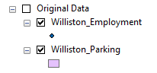

Figure : Original data grouped as "Original Data"

Load the Generator and Parking data created by the tool. This data is found in the “Working_Data.gdb” geodatabase (/2_Data/ Working_Data.gdb, Figure 27).

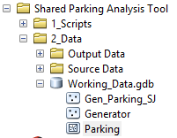

Figure : Generator and parking data created by the Generate Parking Preference tool

Group the new data as a logical description of this location, e.g. Maple Tree Place. This data will only contain the locations selected when the Generate Parking Preference tool was run.

This data also contains additional fields with unique identification (UID) numbers for each employer and parking lot

* Generator contains “Gen_UID”
* Parking contains “Lot_UID”

These UIDs are used in parking lot preference files created in the output folder:

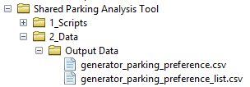 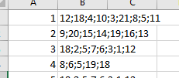

Figure : Parking lot preferences by generator

People visiting Gen_UID 1 would first park in Lot_UID 12, then Lot_UID 18, etc.

## Create Generator and Parking Lots Input Files

### Generator File

This step will create a new Generators file similar to the Excel generator files provided with the tool. Open *Generators.xlsx* from /2_Data/Example Data/ and Save As to the Source Data folder (/2_Data/Source Data/).

In the Attribute Table of the new *Generator* file (ArcMap), export it as a dBase Table called *Generators.dbf*, but do not add it to the map if prompted.

In Excel, open the newly created *Generators.dbf* file so that both this dbf and the *Generators.xlsx* file are open.

In the **dbf** tab of *Generators.xlsx*, select all data from row 2 downward and press the “Delete” key. Do not right-click and select delete because this may break formulas in the workbook.

Copy and paste all data, including the headings, into cell A2 of the **dbf** tab of *Generators.xlsx*.

Copy all cells under the OBJECTID column (**dbf** tab) into the Location column of the **Generators**tab.

Open the *_list.csv file from root/2_Data/Output Data/ (by default this file is named generator_parking_preference_list.csv). Copy the first two columns from this file into the **ParkLots** tab of *Employment.xlsx*. The Parking Lots column on the **Generators** tab should populate automatically.

On the **Generators** tab, the user will need to modify data which does not populate automatically. Changes or check the following:

* If there are more rows of OBJECTID numbers than rows of formulas, copy and paste the formulas down until they match the number of OBJECTID numbers.
* In the LUC column, assign each row an LUC value from the **LandUse** tab. These are the land use code (LUC) numbers for this tool. ULI Second Edition does not have land use codes, so these numbers are arbitrary.
* Once the LUC values are entered, the Units column will populate automatically.
* The Size column automatically chooses the square footage of the generator from the **dbf** tab. If the units for a row are not GLA (gross leasable area) or GFA (gross floor area), then the user will need to enter the units manually, e.g. number of seats in a Cineplex.
* Check the square footage of the other generators. The data may not be accurate.
* The ParkingLots column lists parking lots in order of proximity with the closest lots first. However, this may not be the best order of preference. The user should check the parking lots list for each row to ensure that the lots are listed in the correct order of preference, that all lots relevant to a particular generator are included in its row, and that lots which should not be associated with a generator are not included.
  + In Office 365, the Excel function TEXTJOIN() can be used to concatenate a range of strings with a delimiter in between. If the user finds it easier to put each parking lot number in a separate cell, use TEXTJOIN() or CONCATENATE() to combine them.

### Parking Lots File

This step will create a new ParkingLots file similar to the Excel ParkingLots files provided with the tool. Open *ParkingLots.xlsx* from /2_Data/Example Data/ and Save As to the Source Data folder (/2_Data/Source Data/).

In the Attribute Table (ArcMap) of the new *Parking* file, export it as a dBase Table, but do not add it to the map if prompted.

Open the newly created *Parking.dbf* file and the *ParkingLots.xlsx* file in Excel.

In the **dbf** tab of *ParkingLots.xlsx*, select all data from row 2 downward and press the “Delete” key. Do not right-click and select delete because this may break formulas in the workbook.

Copy and paste all data, including the headings, into cell A2 the **dbf** tab of *ParkingLots.xlsx*. The top left cell should be A2 so that the numbers above the column headings are still present.

Copy all cells under the Lot_UID column (**dbf** tab) into the Lot_UID column of the **Lots** tab.

The “Name” and “Space” tab should populate automatically.

If there are more rows of OBJECTID numbers than rows of formulas, copy and paste the formulas down until they match the number of OBJECTID numbers.

## Create Adjustment Factors File

The adjustment factors file contains all possible combinations of adjustment factors for all land uses. It is a *.p[2] file created by the generate_parking_factors.py script. This script reads an excel file containing the possible factor values across dimension with each dimension stored on a separate tab[3]. The script creates a pandas[4] DataFrame[5] to store and access these adjustment factors.

The user can run this script from the ArcMap tool “0) Create Adjustment Factors” in the Parking Analysis Tools toolbox. The user chooses the excel file which contains these factors – in this case *Parking Demand and Adjustments.xlsx* in the Source Data folder. To create a new factors.p file, first adjust the factors in *Parking Demand and Adjustments.xlsx*. The user may make changes such as adding a land use type or changing a parking generation ratio. A user should be familiar with the shared parking methodology and input data before making these changes.

1. Smith, Mary S. *Shared Parking*, Second Edition. Washington, D.C.: ULI-the Urban Land Institute and the International Council of Shopping Centers, 2005.
2. This is a pickle file which can be read by the python programming language. See the file generate_parking_factors.py and <https://docs.python.org/3/library/pickle.html> for more information.
3. See the excel file “Parking Demand and Adjustments.xlsx” in the Source Data folder
4. <https://pandas.pydata.org/>
5. <https://pandas.pydata.org/pandas-docs/stable/reference/api/pandas.DataFrame.html>